 | The grass  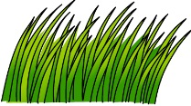 | The river  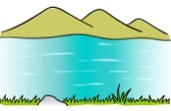 | The mud  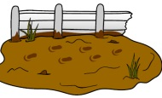 | The forest  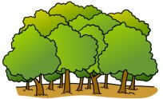 | The snowstorm  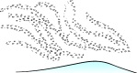 | The cave  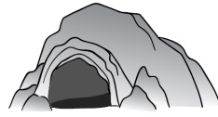
Mrs Vial
Alison
Victoria
Nicolas
Kevin

 | The grass | The river | The mud | The forest | The snowstorm | The cave
Mrs Vial
Alison
Victoria
Nicolas
Kevin

 | The grass | The river | The mud | The forest | The snowstorm | The cave
Mrs Vial
Alison
Victoria
Nicolas
Kevin

