The 2016 American elections
- What is the name of the President of the USA? …………………...............
He is the................th President of the USA.
- What is his party? …………………………………………………………...
- What are the two main parties in the USA ?
- ……………………………………………………………………………..
- ………………………………………………………………………………
- What are the symbols of these two parties ? Where did these symbols originate?
- ......................................................................................
- ......................................................................................
- What is the date of the presidential elections this year ? ……………………………………..
- How often do presidential elections take place (how long is the President's term)? ……………………………………………..
How many times can a President be re-elected? ................................................................................
- Who can become a candidate ? ……………………………………………………………….
…………………………………………………………………………………………………….
……………………………………………………………………………………………………………………………………………
………………………………………………………………………………………………………………………………………….

- Give the name of this year’s 5 candidates and their respective parties.
- …………………………………………………………………….
- ………………………………………………………………………
- ……………………………………………………………………..
- ………………………………………………………………………
- ……………………………………………………………………….

How do American people vote?
- What is « a ticket » … read the definition to the bottom of the page ( us elections) ? …………………………………………………………………………
- What is « a ballot » ? …………………………………………………………………………….

- Do ordinary Americans directly vote for the President?
……………………………………………………………………………………………………
- In France, voters go to the polls to elect the President, but in the USA, voters go to the polls to elect
the Electoral College
What is it ?.............................................................................................................................
What do these people do ?....................................................................................................
Have a look at this map
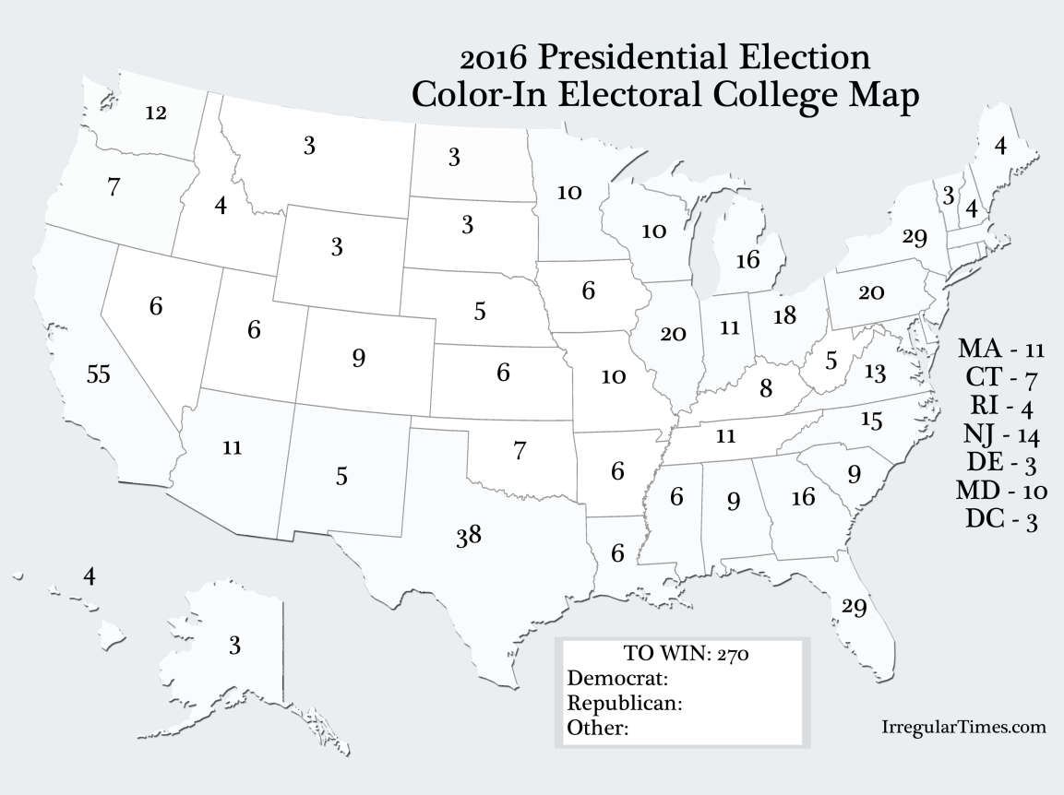
What do the numbers in each State correspond to?

12.When is Inauguration Day ? …………………………………………………………………..
What is it?...................................................................................................................

