How the rail freight industry works
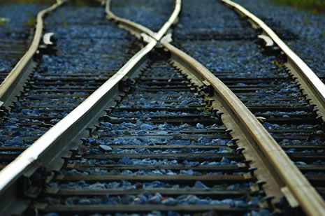
In Britain rail freight is a private sector activity. Unlike the vast majority of passenger rail services where private companies run services under a franchise arrangement with DfT, rail freight is a commercial service provided by private freight train operating companies for corporate customers, sometimes through an intermediary logistics service provider.
The Government’s role in rail freight is to set the safety and regulatory environment. It also gives grants to support environmental benefits of certain traffics being moved from road to rail if that would bring a proven societal benefit to the environment.
How the rail freight industry operates
Network Rail is the owner and operator of the commercial track infrastructure in Great Britain. This includes connections to over 700 private sidings and over 350 sites and depots leased to freight train operators. The Channel Tunnel and associated rail routes such as High Speed 1 are separately owned.
The Office of Rail Regulation (ORR) is the industry's economic and safety regulator. ORR has a specific duty to protect the interests of all rail users of the railway network. This includes the protection and enhancement of the rail network and services for freight. ORR also considers applications for freight train operator licences and considers track access agreements (to timed slots on the rail network to run freight trains) and sets the menu of track access charges between freight train operating companies and Network Rail. ORR also is the body to whom appeals are made where a party to an access agreement disputes the price or conditions that they have been quoted. This includes balancing the access of passenger and freight services to the network.
Freight services are provided by Freight Operating Companies (FOCs). They provide traction and rolling stock and in some cases also modal transfer and product loading/unloading facilities. Additionally, Logistics Service Providers (LSPs) often act as intermediaries between shippers and freight operating companies.
Rail freight interchanges
Except for certain bulk commodities, which largely already use rail, few traffics can complete their entire journey by rail alone. Therefore the customer needs to select the most appropriate point where goods are put on the railway or taken off it. The interchange used will depend on whether a customer is a regular or occasional user and the volume and type of product that is to be moved. These interchanges can be of a number of different types:
- Private sidings: these can be at a factory, works, warehouse or distribution depot, often owned or leased by the shipper or operator.
- Large strategic rail freight interchanges: capable of handling intermodal or conventional wagons – examples include Daventry International Rail Freight Terminal, Leeds, Manchester, Birmingham, Hams Hall,Wakefield Europort and Glasgow Eurocentral. These strategic interchanges include other facilities such as wagon repair, fork-lift and mechanical handling, storage facilities, personnel hire and canteen facilities: what is known as a 'freight village'.
- Smaller road/rail interchanges: where the trans-shipment between road and rail takes place, for example, the transfer of containers.
Rail freight operators
DB Schenker is the largest operator overall. It is organised into four main divisions.
- Network: for intermodal and logistics services
- Energy: coal haulage for the electricity supply industry
- Industrial: movement of heavy raw materials for industry such as metals and petroleum
- Construction: for the construction and waste industries
Freightliner is the largest operator in the container market. It has two divisions.
- Freightliner International: the traditional intermodal container business
- Freightliner Heavyhaul: the developing coal and bulk products haulage division of Freightliner Group. This is competing with DB Schenker as the traditional incumbent operator of these type of services
DRS (Direct Rail Services) is a wholly owned subsidiary of the Nuclear Decommissioning Authority. Although set up at the time of rail privatisation to ensure the continued ability to haul spent nuclear fuel from the nuclear power station decommissioning programme, this now accounts for only 40 per cent of its business. DRS has diversified into domestic intermodal and retail traffic, much of it newly won to rail.
GBRf (GB Rail Freight) is part of the Eurotunnel group. It provides both intermodal container and bulk coal haul services in addition to specialist infrastructure freight services. Other smaller rail freight companies such as Colas Rail have also started operation in Britain. This has all led to a competitive market with investment in excess of £1.5 billion in over 400 new locomotives and 3,000 wagons to meet customer demands and growth since the late 1990s.
Logistics service providers
Multimodal logistics service providers offer a variety of services to companies wishing to transport goods and are especially useful when considering multimodal distribution, as they have much expertise in different modes and can manage the whole process for customers.
The Malcolm Group provides integrated logistics solutions incorporating warehousing and handling services, road and rail distribution and supply chain management.
John G Russell (Transport) Ltd offers third party warehousing and transport, including the delivery of raw materials straight to production lines to the clearing of finished goods either to warehouse or for onward distribution.
Eddie Stobart Ltd offers distribution and storage services by road and rail.
The Potter Group offer multimodal road and rail based storage and transport services.
Currently there is no commercial rail freight provision either domestically or cross border in Northern Ireland.

